**DAILY ONLINE ACTIVITIES SUMMARY**

|  |  |  |  |  |  |  |  |  |
| --- | --- | --- | --- | --- | --- | --- | --- | --- |
| **Date:** | **20/07/2020** | | | | | **Name:** | **NAIPUNYA VINOD NAIK** | |
| **Sem & Sec** | **IV SEM & A SECTION** | | | | | **USN:** | **4AL18CS050** | |
| **Online Test Summary** | | | | | | | | |
| **Subject** | | 1. **MATHS DESCRIPTIVE TEST** 2. **MATHS TEST_1(IMPROVEMENT)** | | | | | | |
| **Max. Marks** | | **1) 30**  **2)30** | | **Score** | | | 1. **N/A** 2. **N/A** | |
| **Certification Course Summary** | | | | | | | | |
| **Course** | **1) WEBINAR ON RPA**  **2) THE BEGINNERS GUIDE TO CYBER SECURITY 2020.**  **3) HOW THE INTERNET WORKS AND WEB DEVELOPMENT PROCESS** | | | | | | | |
| **Certificate Provider** | | | **1) OXFORD COLLEGE OF ENGINEERING**  **2) UDEMY**  **3) UDEMY** | | **Duration** | | | **1) 1 HR 15 MIN**  **2) 2.5 HRS**  **3) 37 MIN** |
| **Coding Challenges** | | | | | | | | |
| **Problem Statement: NO PROBLEM STATEMENT GIVEN TODAY** | | | | | | | | |
| **Status: EXECUTED** | | | | | | | | |
| **Uploaded the report in Github** | | | | | **YES** | | | |
| **If yes Repository name** | | | | | <https://github.com/naipunya-naik/daily-progress-report> | | | |
| **Uploaded the report in slack** | | | | | **YES** | | | |

Online Test Details: (Attach the snapshot and briefly write the report for the same).

THE 2ND I.A OF MATHS DESCRIPTIVE TEST WAS CONDUCTED ON 20 JULY, 2020.

* SUBJECT:- COMPLEX ANALYSIS,STATISTICAL METHODS AND PROBABILITY
* SYLLABUS:- MODULE 2
* TOTAL MARKS:- 30
* NO.OF QUESTIONS:- 3
* FROM 9.30 AM TO 10.15 AM
* DURATION:-45 MIN
* THE MARKS WILL BE PROVIDED SOON.
* 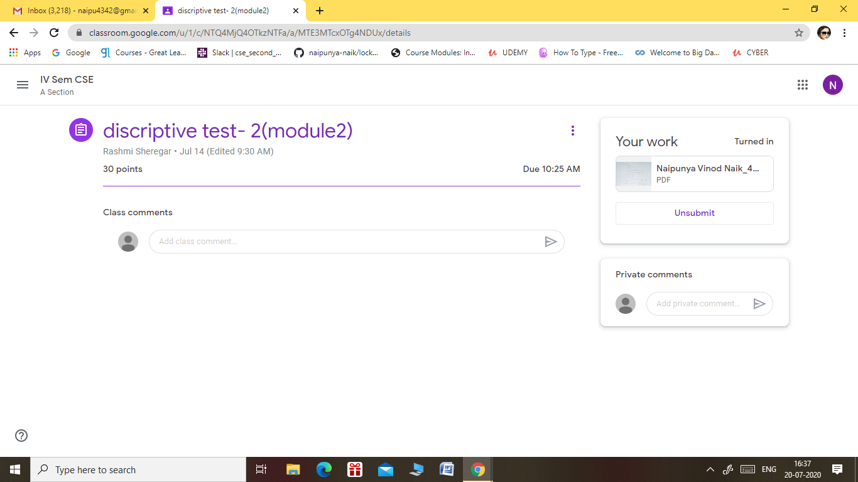

2)THE MATHS TEST_1(IMPROVEMENT) WAS CONDUCTED ON 20 JULY,2020.

* FROM 3 TO 4.30 PM
* DURATION:- 1.5 HRS
* NO OF QUESTION:- 30
* EACH QUESTION CARRIED 1 MARK
* SYLLABUS:- MODULE 4
* THE RESULT WILL BE PROVIDED SOON.

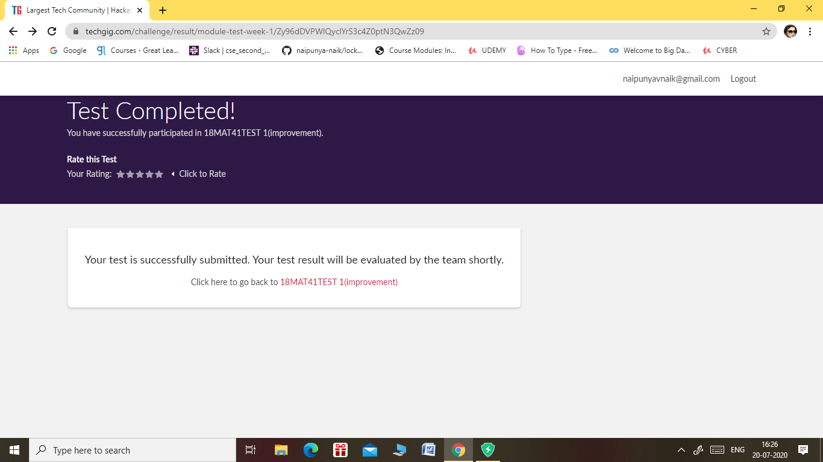

Certification Course Details: (Attach the snapshot and briefly write the report for the same).

1. WEBINAR ON RPA.

TODAY I ATTENDED A WEBINAR OF RPA ON GOOGLE MEET FROM 2.15 TO 4 PM.

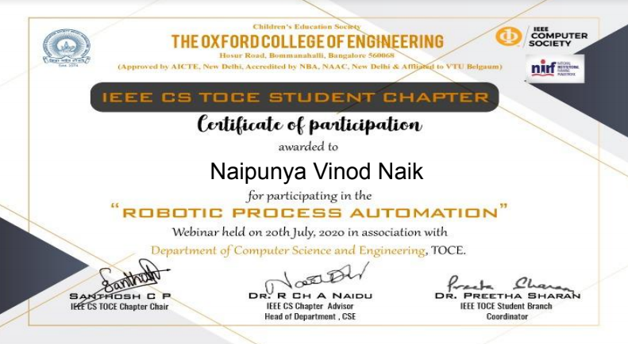

1. CERTIFICATION COURSE NAME:- THE BEGINNERS GUIDE TO CYBER SECURITY 2020.

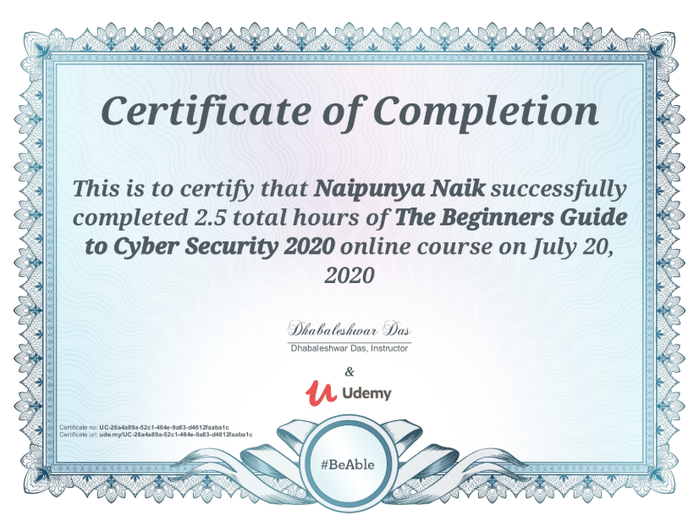

1. CERTIFICATION COURSE NAME:- HOW THE INTERNET WORKS AND WEB DEVELOPMENT PROCESS

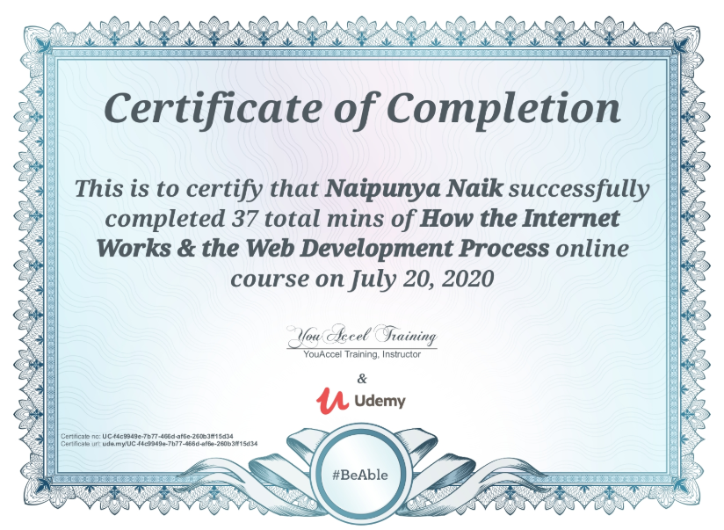

Coding Challenges Details: (Attach the snapshot and briefly write the report for the same).

NO PROBLEM STATEMENT GIVEN TODAY